Water Use Data from Environment and Climate Change Canada

<https://www.ec.gc.ca/eaudouce-freshwater/default.asp?lang=En&n=EFDA57C6-1>

**What is this repository?**

Environment and Climate Change Canada is a bilingual, government-sponsored website with information about Canada’s natural resources and climate change statistics and governmental regulations. This is a massive scope—within this larger site (see path:)



there is a repository of data about water use, in which are eight links to data sets about water quality and water mapping.

**What are its strengths?**

* Intuitive to navigate; there is just one main page (“Online data”) with links to each data set.
* ECCC is careful to disclaim that these data sets are not their property, and may change
* The data sets themselves are housed within the ECCC website, and those individual pages are laid out very nicely, with an introduction, publisher information, and a table (see below) containing the actual resources, with further information on the right-hand side bar. Easy to use.

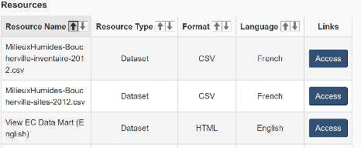

* After clicking “access” you are taken to a new page, which is also laid out very nicely, with an abstract, a link to metadata, and links to data sets.

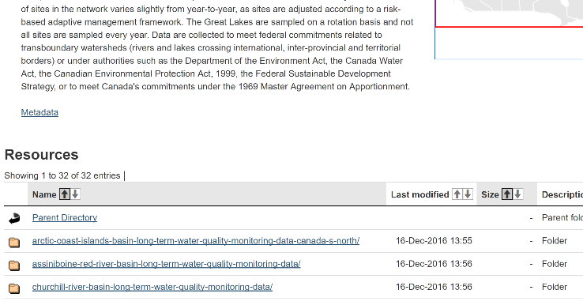

What are its weaknesses?

* This is not an in-depth repository. It is not highly organized or structured like an academic research site.
* You have to follow a series of four links before actually downloading a dataset, and I believe that there is some redundancy in the occurrences of links. For example, this is on the first page:

and I found this after clicking through to an entirely different data set:



**What can we learn from this repository?**

* I love how easy to use this is for the lay person. The web page structure is unintimidating and each link is well-labeled and clear.
* I don’t love that you have to fall down a link rabbit hole just to get to the actual data set.
* I’m not sure how to have the clarity without having the never-ending story of links.